|  |  |
| --- | --- |
| **Mt Lindesay, Denmark in the Great Southern, Western Australia.**  Our philosophy on our family farm at Mt Lindesay is best described as ‘agroecological wellbeing’. Agroecology simply means the ecology of our farm. We focus on the wellbeing of the landscape, our family who are sustained by it, and those who enjoy our place and what we grow. |  |

Over the last 40 years on our family farm in Denmark we have transformed a degraded oversimplified agroecosystem into a productive sheep and organic vegetable farm that is a veritable arboretum.

As farmers we learn by doing. We farm and foster world-class research on organic functional foods that grow within our farm’s unique agroecosystem. As we are constantly learning, we improve how we nurture a healthy agroecology to grow tastier, healthier, and more nutritious food.

As custodians we hope to sustain the wellbeing of our farm agroecology, our own family, and those we share our unique foods we grow at Mt Lindesay.

Sincerely,

Mark, Julia, Pauline, our kids, and our extended family.



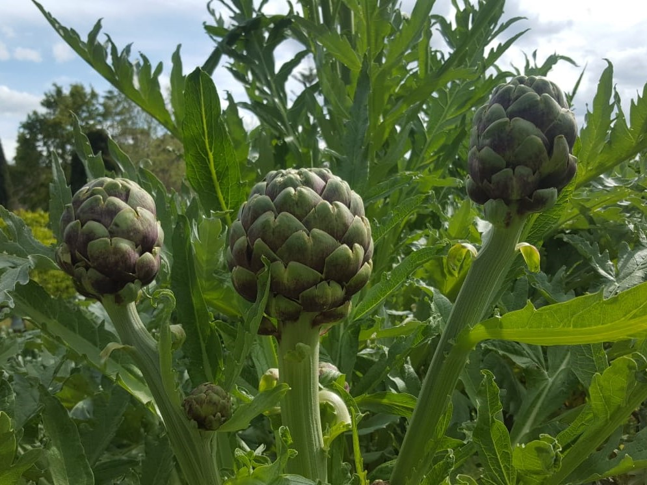

Our globe artichoke inflorescences on the farm at Mt Lindesay.

|  |  |
| --- | --- |
| **Meal ideas.** Globe artichokes enhance feelings of satiety during and after a meal. It is a fantastic entrée with dips. It is delicious roasted, steamed, boiled, baked, or preserved. Our own favourite is to trim and mix with olive oil, spices, and garlic, then vacuum seal for suis vide at 85 oC for 2 ½ hours in a large pot. Once cooled we store them sealed in the fridge for days for a gourmet snack reheated in seconds. The image shows the artichoke before and after a trim. |  |

**Storing and preparing globe artichokes.** Stored best submerged in water with a crushed whole lemon to soak for a few minutes to even for a couple of days (longer you get a slight tang from lemon juice and the natural yeasts). They are so many ways to prepare them with practice. Remove the ‘choke’ when ‘hairy/spiky’ and slice off woodier portions to your preferences. Younger artichokes are more tender, lighter in colour, and can be eaten whole. Darker green sections are healthier, although more bitter. Larger and older artichokes will become more fibrous.

**Globe artichokes at Mt Lindesay.** We have developed our own diverse breeding lines grown organically within rainfed pastured paddocks with supplementary water from the solar pump on our own waterways with no-one upstream. We plant and harvest by hand. A stunning ornamental plant.

**Globe artichoke history and health.** Globe artichokes (*Cynara cardunculus var. scolymus L.*) were domesticated by the ancient Romans for its smooth and mild nutty flavour. It is a rich source of polyphenols, minerals, and very long chain inulin. Several clinical studies show the total antioxidant capacity of artichoke flower heads and leaves is one of the highest reported in plants, and it has a long history of traditional medical use as a diuretic, hepatostimulant, and a treatment for dyspepsia and mild hypercholesterolemia (Mediterr. J. Nutr. Metab. 2010 3 197-201).



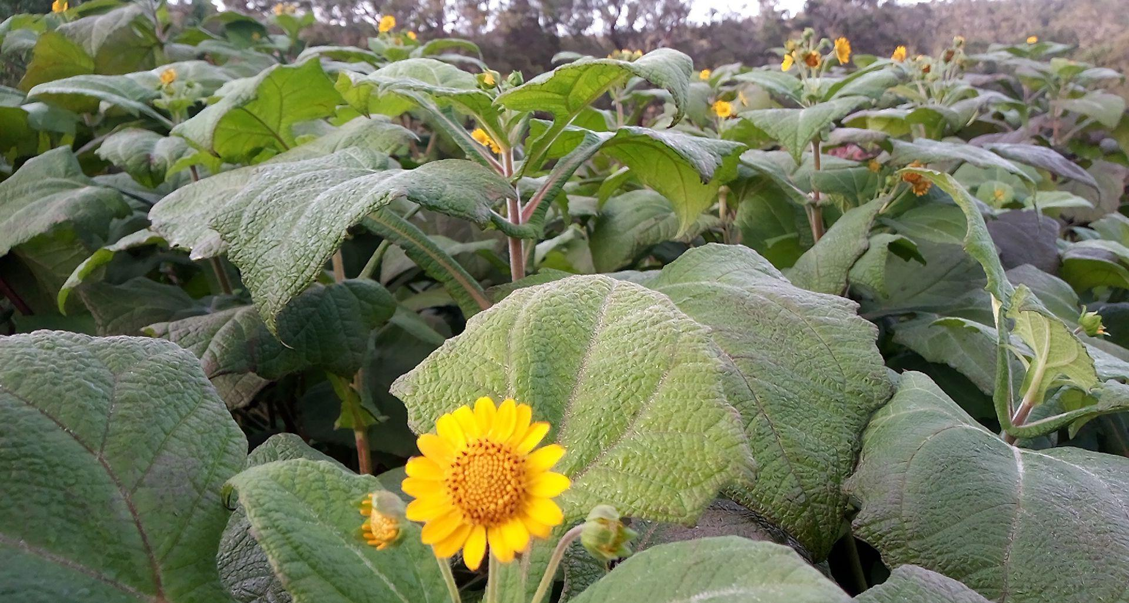

Our flowering yacon weeks before harvesting the root at Mt Lindesay.

|  |  |
| --- | --- |
| **Meal ideas.** While it has risen to prominence as a boiled syrup, fresh yacon is unsurpassed when raw. It also retains a crisp light texture with a melon-like moisture even in curries and stews. When cooked it has a richer flavour and a softer texture. It’s perfect for an addition of a juicy crunch when sliced or grated into salads, desserts, biscuits, or cakes. One favourite is to cube it harvested fresh mixed raw with yoghurt or icecream. Pictured is raw yacon sliced in the foreground, and covered in yoghurt in the glass.  **Storing and preparing yacon.** Yacon can be simple. It can be stored chilled, room temperature, even for days in the sun to improve sweetness and colour. Prepare like a potato by scrubbing or peeling skin. The texture after freezing when defrosted is like watermelon. |  |

**Yacon at Mt Lindesay.** A friend gave us a single plant many years ago. We grow them organically into very large specimens as large as a person. We replant tubers by hand each year in prepared soil and harvest by hand in winter. We water from the solar pump on the fenced revegetated gully dams.

**Yacon history and health.** Yacon (*Smallanthus sonchifolius*) was cultivated by Indigenous pre-Incan people in South America as a crisp mildly sweet-flavoured root vegetable. Yacon root and leaf is also a traditional medicine used for diabetes, constipation, and more recently weight management due to the high fructooligosaccharide and inulin levels. In vitro and in vivo studies demonstrate potential health benefits and dietotherapy applications to prevent chronic disease (Nutrients 2019 11 2632 doi:10.3390/nu11112632).



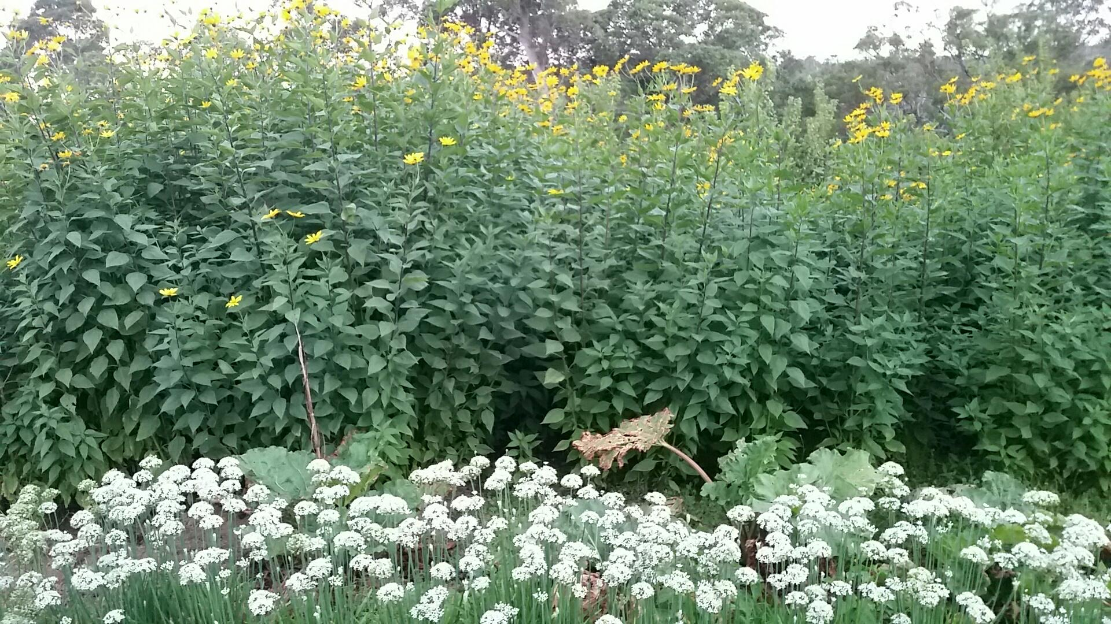

Sunchokes with yellow flowers alongside rhubarb and white garlic chive flowers at Mt Lindesay.

|  |  |
| --- | --- |
| **Meal ideas.** Commonly used like a potato substitute, it is excellent in creamy soups, stews, curries, roasts, or as wedges/chips. It doesn’t fall apart when cooked like a potato, so retains a soft but firm texture. The high inulin means ‘gas’ for many, which is a result of feeding the natural ‘good bacteria’ in your gut via healthy fermentation processes. Use it wisely. Over time your ‘improved gut biome’ seems to produce less gas for eating the same amount of sunchoke. | Grilled duck, eggplant, sesame sunchokes. |

**Storing and preparing sunchokes.** Sunchokes are also known as Jerusalem artichokes, and they store well in the fridge for weeks. The complex tuber structure needs careful cleaning to remove soil. They are simply sliced, chopped, or grated to the desired size, which can be done before or after cooking.

**Sunchokes at Mt Lindesay.** We were given sunchokes by our neighbour around 40 years ago and we have enjoyed it ever since. It grows prolifically organically as a very tall plant over summer. Kids love to play within the dense and lush foliage when it is growing, as do many small birds.

**Sunchoke history and health.** Sunchoke (*Helianthus tuberosus*) was domesticated for its tubers and leaves by Indigenous North Americans, and is used as a traditional medicine for diabetes. Numerous studies show sunchoke has applications as a prebiotic dietary fibre, a neuroprotector, a fat substitute due to the creamy texture, and a sweet sugar substitute that can both prevent type-2 diabetes onset. It is rated zero on the Glycaemic Index. (J. Food Res. 2017 6(5) 69-84.)



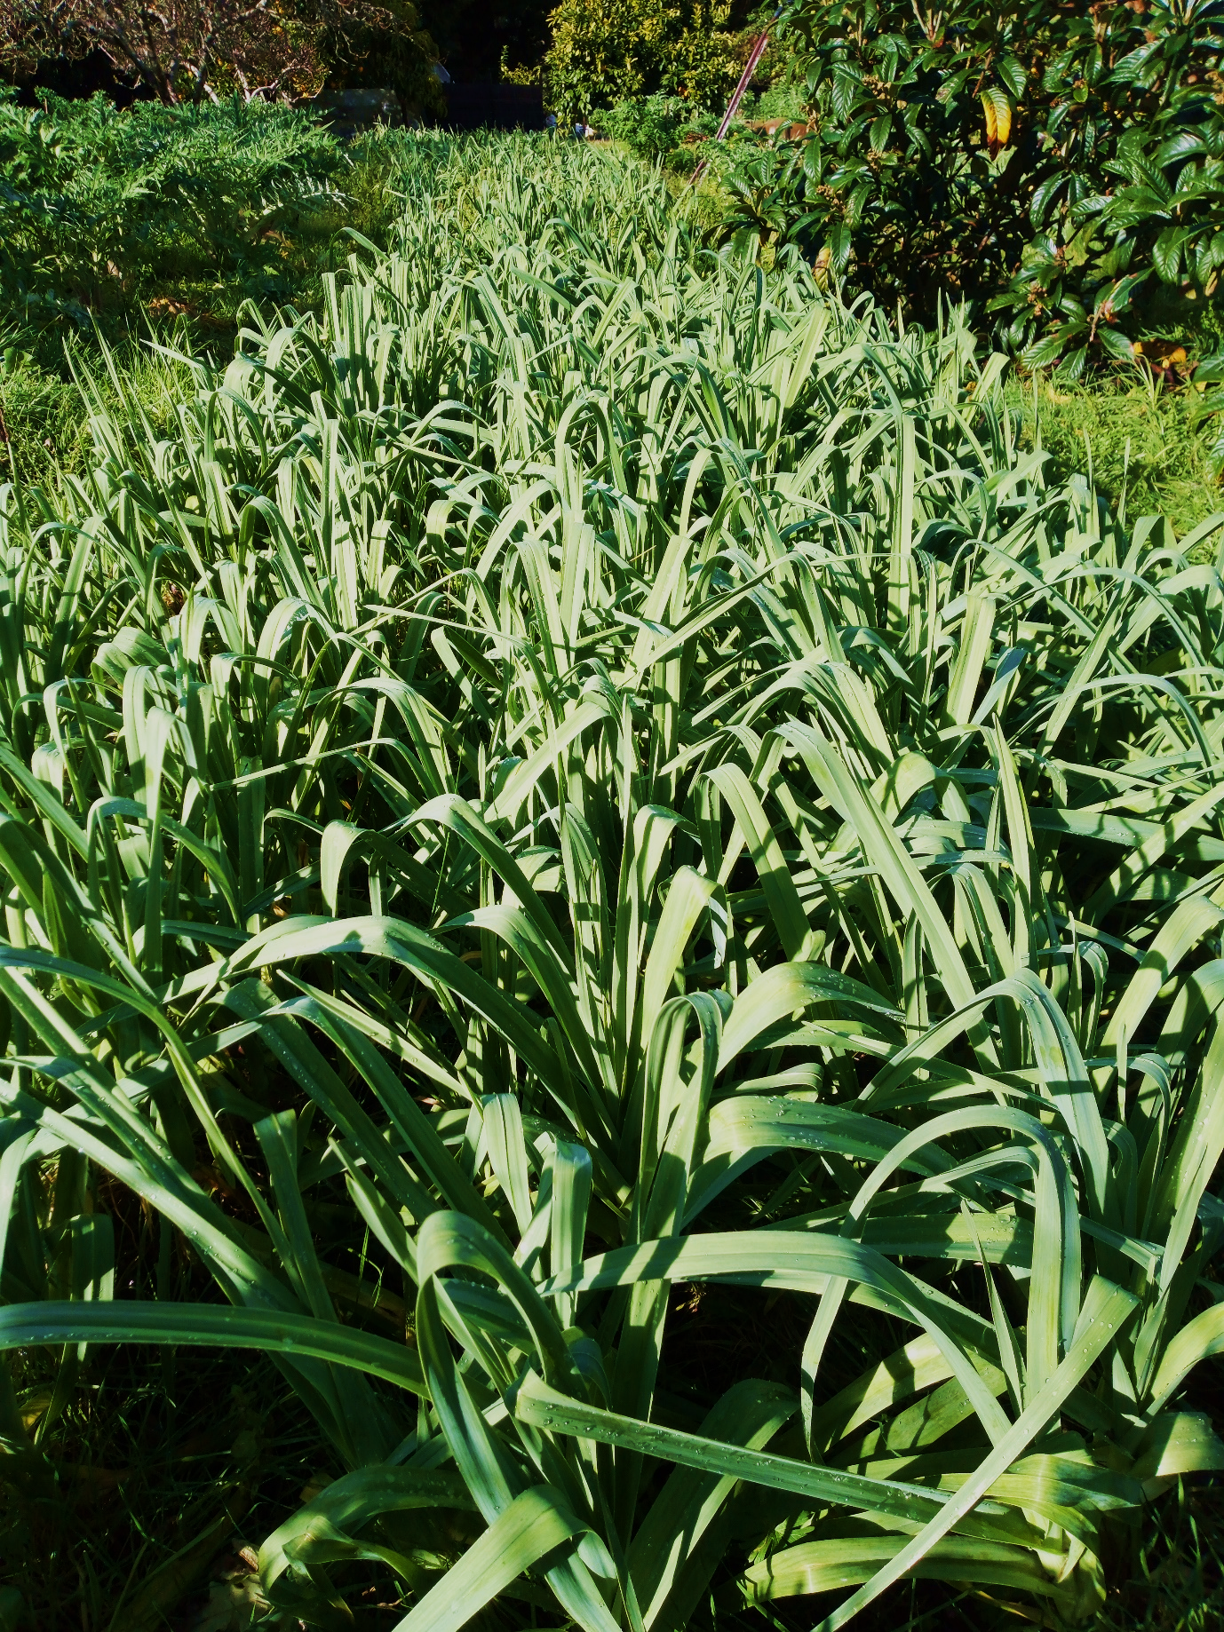

Elephant garlic grows well within other crops and trees at Mt Lindesay.

**Meal ideas.** It’s delicious roasted as it caramelises perfectly. It’s great steamed, and the aroma is wonderful in rice dishes. It is impressive when added late in the cooking process to add even more flavour to any dish and to show off the enormous bulb. The immature flower stems called scapes are a delicacy, and it’s culinarily similar to a deeply garlic flavoured asparagus. The garlic may stick to a frying pan in oil.

**Storing and preparing elephant garlic.** It stores extremely well for a lot longer than other garlics at room temperature in the dark – even more than a year. It’s very easy to peel as the skin falls off.

**Elephant garlic at Mt Lindesay.** Our garlic was growing wild in the garden and pasture when we bought the farm around 40 years ago. We resow bulbs as an organic rainfed crop planted and harvested by hand, giving them a good start with our home-grown compost. They are an impressively large bulb and are closely related to leek. We now seldom use our other garlics, as the elephant garlic is so convenient and flavourful.

**Elephant garlic history and health.** Elephant garlic (*Allium ampeloprasum var. ampeloprasum*) has been cultivated in Asia for centuries for its medical uses and slightly mild flavour for use raw or cooked. Numerous health applications include as a potent antimicrobial for food-borne pathogens, antibacterial effects on common bacteria, and cancer treatment by inhibition of osteosarcoma (U2O5) cell invasion, proliferation, and cancer cell activity (Iran J. Basic. Med. Sci. 2013 Oct 16(10) 1088-1094.)

